Tangled Feet seek Trustee for initial 3 year tenure with experience of Legal, HR and/or Finance and a strong connection with Luton or Bedfordshire

Being a trustee is unique way to support creativity, culture and charity to blossom and survive. At a small arts charity like Tangled Feet it’s a great way to learn all about making arts events happen, developing and supporting young peoples lives and using creativity as a way to celebrate place and community. We are a small, committed and friendly team and Board of Trustees and any new Trustee will gain much from their experience with us. You do not need to have been a Trustee in the past or have any experience in charities to take on this role.
About Tangled Feet
Tangled Feet is an artist-led ensemble based in Luton, creating and touring work locally, nationally and internationally. We create original theatre through a collaborative working methodology that celebrates physicality and ensemble skills. TF is an artist-led ensemble - one of the few operating in the UK. We founded our company as a group of friends in 2003 but the company now encompasses a broad and diverse group of artists and practitioners, many of whom have worked with us for many years. We are a registered charity and an Arts Council England National Portfolio Organisation. We create performances inside and outdoors: in theatres, on the streets, up the side of buildings and inside schools. We love sharing the creative process with new people and younger artists as an integral part of our production process, and in workshops, residencies and participation projects. Alongside this, we have built an expansive delivery of therapeutic provision which supports young people with their mental health.
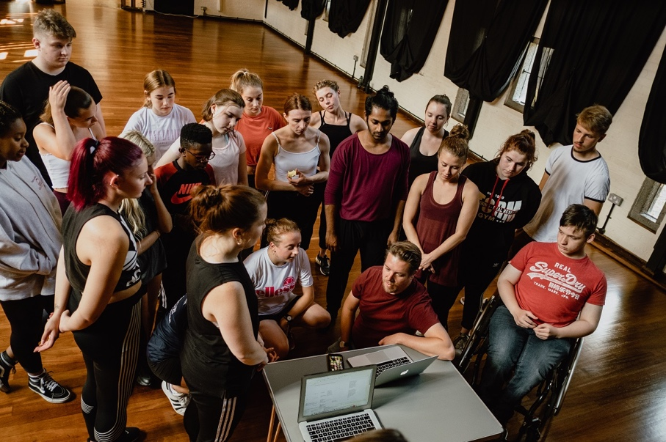
Tangled Feet is an ensemble of artists but is led by Co-Directors Nathan Curry and Kat Joyce. They all work part- time.
Person Specification:
-A commitment to Tangled Feet, its aims and objectives
-An understanding of the duties and responsibility of a Trustee
-A willingness and availability to devote the time and effort to the duties
-Ability to offer personal skill
-Ability to think creatively and offer strategic view
-Ability to offer honest, independent and good judgement
-Ability to work as a team, offer personal conviction but accept majority decision-making
-To champion Tangled Feet
Duties

-Advisor and counsel for the company’s work
-To watch and support the company’s work
-Advise Tangled Feet on matters financial, HR or legal (according to applicants skillset) and working closely with TF team members on this area outside of meetings (on phone, by email and infrequent extra meetings)
-To ensure Tangled Feet operates within Company and Charity Law, ensure prudent financial management and best practice accounting
-To ensure Tangled Feet have comprehensive policies of working
-To support the definition and delivery of Tangled Feet’s employment policies, pay proposals and best practice working environment
-Set priorities and strategies, alongside the Tangled Feet Senior Management Team for all of the work of the company
-Attend four quarterly meetings a year in Luton, London or online (6.30-9pm weekday evenings, hybrid option available)

The current Tangled Feet Board of Trustees are:
-Beccy Allen (Chair), Arts and Wellbeing Director/Deputy CEO, St Margaret’s House,
-Catherine McKinney (Vice Chair), Exec Director Park Theatre
-Binita Walia, PR Consultant and Artist, The Space Between
-Rae Rahman, Grant Manager, Bedford and Luton Community Fund
-Adeyinka Akinrinade, Actor and Producer
-Sophie Scull, Executive Producer at English Touring Theatre
-Sandro Forte, CEO Forte Financial
-Sam Edmunds (Young Trustee), theatre maker
Please send an email articulating why you’d like to join the Board as well as a brief CV or statement of your experience to contact@tangledfeet.com by 24th June.
If you’d like to discuss the role with Co-Directors Nathan Curry/Kat Joyce email contact@tangledfeet.com or Chair, Beccy Allen please email beccyallen@gmail.com

